DATA ENCODING TECHNIQUES
An Assignment on Digital and Analog Data Encoding Methods
Course: Data Communication and Computer Networks
Topic: Encoding, Decoding, and Digital-to-Digital Encoding Schemes
Date: September 2026

Table of Contents

1. Introduction to Encoding and Decoding
Encoding is how we take data — text, speech, video, whatever a source produces — and turn it into electrical, optical or electromagnetic energy that can actually travel across a wire, a fibre or open air. Decoding is the reverse: the receiver turns that signal back into usable information. The two always come as a pair, and the transmitter and receiver have to agree in advance on exactly which scheme they're using, or the signal is just noise.
When engineers pick an encoding scheme, they're balancing bandwidth efficiency, noise resistance, self-synchronisation (letting the receiver recover a clock on its own), simple circuitry, and sometimes error detection. Different applications weigh these differently, which is why so many schemes exist.
This assignment briefly covers the main encoding categories, then focuses on digital-to-digital schemes: NRZ, Bi-phase (Manchester), and block coding (4B/5B, 8B/6T).

2. Data Encoding
In digital transmission specifically, encoding means using patterns of voltage or current to represent 1s and 0s on a link. The chosen bit pattern is called a line code, and applying it is line encoding.

2.1 Common Types of Line Encoding
Scheme | Voltage Levels | Key Characteristic | Typical Drawback
Unipolar | 1 (On/Off) | Simple; uses one polarity only | DC component; poor synchronisation
Polar | 2 (+V / −V) | Reduced DC bias vs. unipolar | Still loses sync on long bit runs
Bipolar (AMI) | 3 (+V / 0 / −V) | Zero has no DC component; alternating pulses give error detection | Long runs of 0s still cause sync loss
Manchester | 2, with mid-bit transition | Self-clocking; no DC component | Requires twice the bandwidth of NRZ

3. Encoding Techniques — Classification
Encoding techniques fall into four categories, depending on whether the source data and the transmitted signal are analog or digital.

3.1 Analog Data to Analog Signals
Analog data like voice riding on an analog carrier uses modulation: AM varies the carrier's amplitude, FM varies its frequency, and PM varies its phase — all in proportion to the message signal.

3.2 Analog Data to Digital Signals
This is digitisation, done mainly through Pulse Code Modulation (PCM): sample the signal (at least twice the highest frequency present, per Nyquist), quantise each sample to the nearest discrete level, then encode each level as a binary word. Delta Modulation is a simpler alternative that encodes only the change between samples — cheaper to build, but prone to slope-overload or granular noise depending on step size.

3.3 Digital Data to Analog Signals
Digital data sent over an analog-only medium (like the phone network) uses keying: ASK switches the carrier's amplitude, FSK switches its frequency, and PSK shifts its phase (BPSK uses two phases, QPSK uses four to pack two bits per symbol). Quadrature Amplitude Modulation combines ASK and PSK and shows up widely in modems and wireless.

3.4 Digital Data to Digital Signals
This last category matters most for networks — it's how 1s and 0s from a network interface become voltage levels on a cable, no carrier involved. It's the focus of the rest of this assignment: NRZ and its variants, Bi-phase encoding, and block coding.

4. Non-Return-to-Zero (NRZ) Encoding
NRZ represents 1 with High voltage and 0 with Low, and the voltage holds steady across the whole bit interval — it never drops back to a reference level between bits. That makes it bandwidth-efficient, since a transition only happens when the bit value changes. But long runs of identical bits leave the signal flat for a stretch, and with no transition to mark bit boundaries, the receiver's clock can drift out of sync — the classic NRZ weakness.

4.1 NRZ-L (NRZ Level)
The polarity flips only when the bit value changes; each bit maps directly to a voltage level, so the level literally is the bit value.
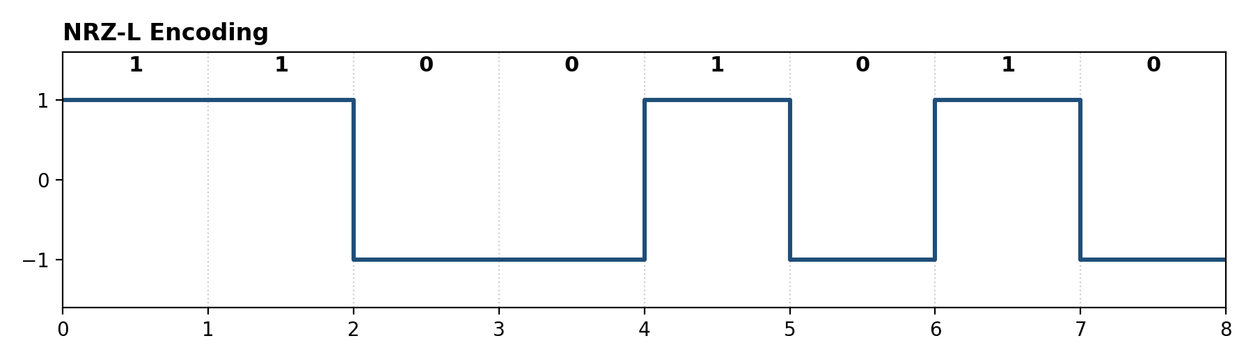
Figure 1: NRZ-L waveform for the bit sequence 1 1 0 0 1 0 1 0 (author-generated illustration).

4.2 NRZ-I (NRZ Inverted)
Here the bit value is tied to a transition, not a level: a 1 flips the level at the start of the interval, a 0 leaves it unchanged. That makes NRZ-I a differential scheme — decoding needs the previous level, not just the current one — and it's immune to the two wires of a twisted pair getting swapped.
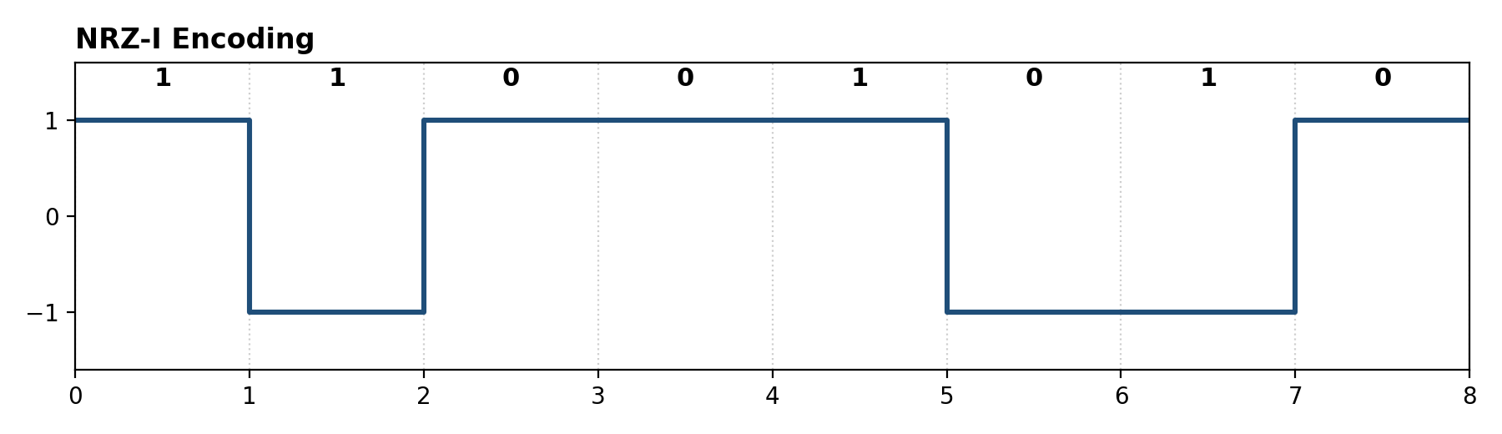
Figure 2: NRZ-I waveform for the same bit sequence 1 1 0 0 1 0 1 0 (author-generated illustration).

4.3 Limitations of NRZ Codes
Both variants suffer the same problem: long runs of identical bits (all 1s for NRZ-L, all 0s for NRZ-I) throw off clock sync. Fixes include a separate clock line, or bit-stuffing/scrambling to break up long runs before transmission.

5. Bi-phase Encoding
Bi-phase encoding fixes NRZ's sync problem by guaranteeing at least one transition per bit interval, checking the level once at the start and once at the middle. That makes it self-clocking — no separate clock line needed. The cost is bandwidth: the modulation rate doubles compared to NRZ at the same bit rate.

5.1 Bi-phase Manchester Encoding
There's always a transition at the mid-point of each interval, and its direction gives the bit: High-to-Low for a 1, Low-to-High for a 0. It's easy to decode and has no DC bias problem, since every interval carries equal positive and negative signal. This was the scheme used in classic 10 Mbps Ethernet (IEEE 802.3).
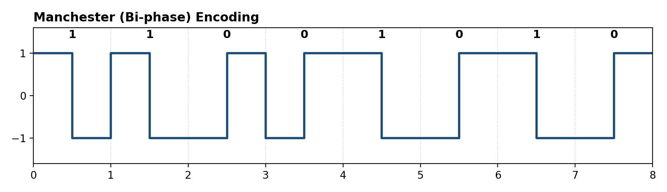
Figure 3: Manchester (Bi-phase) encoding for the bit sequence 1 1 0 0 1 0 1 0 (author-generated illustration).

5.2 Differential Manchester Encoding
The mid-bit transition is still there for clock recovery, but it doesn't carry the bit value on its own. Instead, a transition at the start of the interval means 0; no transition means 1. Like NRZ-I, it doesn't care about wire-polarity reversal. This was used in Token Ring (IEEE 802.5).
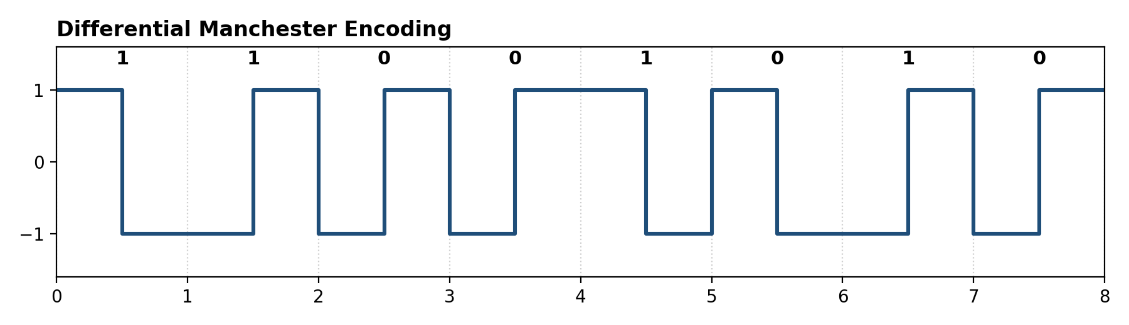
Figure 4: Differential Manchester encoding for the bit sequence 1 1 0 0 1 0 1 0 (author-generated illustration).

5.3 Comparison of Manchester and Differential Manchester
Aspect | Manchester | Differential Manchester
Mid-bit transition | Always present; direction encodes the bit | Always present; used only for clock recovery
Bit value indicated by | Direction of the mid-bit transition | Presence/absence of a transition at the start
Sensitive to wire reversal? | Yes | No
Historic use | 10 Mbps Ethernet (802.3) | Token Ring (802.5)

6. Block Coding
Block coding maps a fixed block of m data bits onto a larger block of n coded bits (n > m). The extra bits aren't wasted — they guarantee a minimum number of transitions, cap runs of identical bits, and keep the signal DC-balanced. These schemes are usually named mBnT, where B is binary and T is ternary (three-level).

6.1 4B/5B Encoding
4B/5B avoids Manchester's double-bandwidth cost while still solving NRZ's sync problem: every 4 data bits become a 5-bit code word, chosen (at most one leading 0, at most two trailing 0s) so that stringing them together guarantees at least two transitions per block once sent as NRZ-I.
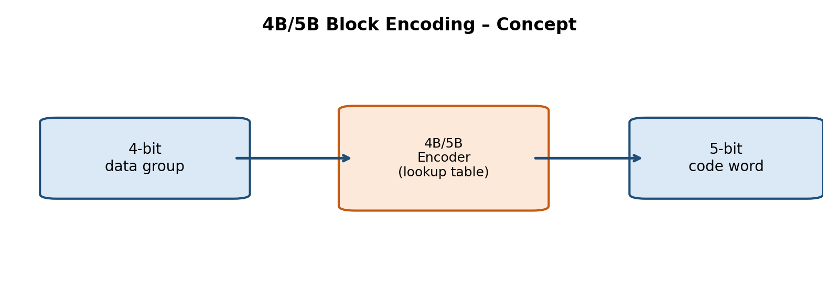
Figure 5: Conceptual block diagram of 4B/5B encoding (author-generated illustration).
Of the 32 possible 5-bit code words, only 16 are needed for the 16 possible 4-bit values, so the rest are reserved for control signals (frame start/end, idle line). 4B/5B with NRZ-I is used in 100BASE-TX Fast Ethernet and FDDI.

6.2 8B/6T Encoding
8B/6T uses more than two voltage levels to pack more bits per signal element: 6 ternary signal elements (3 levels each) represent every 8 input bits — 3⁶ = 729 possible patterns against the 2⁸ = 256 actually needed, leaving 473 spare patterns for DC balance and control symbols. It's used in 100BASE-T4 Fast Ethernet, built to push 100 Mbps over the older Category 3 cabling.

6.3 Worked Example: Encoding the Byte 10110010
Here's how the byte 1 0 1 1 0 0 1 0 looks under three schemes:
Scheme | Rule applied | Resulting behaviour
NRZ-L | Level follows the bit value directly (1 = High, 0 = Low) | Levels change only where the bit value changes
NRZ-I | Transition at start for 1; none for 0 | A transition at every '1'; level holds at every '0'
Manchester | Mid-bit High-to-Low for 1; Low-to-High for 0 | Every one of the 8 intervals has a mid-bit transition
The two consecutive 0s and 1s in this byte produce no transition under NRZ-L/NRZ-I — exactly why they can 'go quiet.' Manchester, by contrast, transitions on every single bit regardless of the data.

7. Summary Comparison
Pulling all the digital-to-digital schemes together:
Scheme | Self-Clocking? | Relative Bandwidth | Typical Application
NRZ-L | No | Low (baseline) | Short-distance digital logic links
NRZ-I | No | Low (baseline) | USB, some magnetic recording
Manchester | Yes | High (2× NRZ) | Classic 10 Mbps Ethernet (10BASE-T)
Differential Manchester | Yes | High (2× NRZ) | Token Ring networks
4B/5B (with NRZ-I) | Yes | Moderate (1.25× NRZ) | 100BASE-TX Fast Ethernet, FDDI
8B/6T | Partially (via code design) | Moderate | 100BASE-T4 Fast Ethernet
Two trends stand out: there's a constant trade-off between self-clocking and bandwidth efficiency (Manchester-type schemes sync easily but cost bandwidth; NRZ is efficient but fragile), and block coding sits in between — a modest amount of redundancy buys good sync without paying the full double-bandwidth cost of Bi-phase encoding.

8. Practical Applications
- LANs — Manchester in classic Ethernet, Differential Manchester in Token Ring, 4B/5B or 8B/6T in Fast Ethernet standards.
- Storage — NRZ variants and run-length-limited codes in magnetic/optical disk recording.
- Telecom trunks — Bipolar (AMI) and its successors B8ZS/HDB3 keep T1/E1 lines timed without a dedicated clock channel.
- USB — combines NRZ-I with bit stuffing to guarantee periodic transitions for clock recovery.

8A. Glossary of Key Terms
Term | Definition
Bit interval | The fixed time allotted to transmit one bit.
Baud rate | Signal elements transmitted per second; can differ from the bit rate.
Self-clocking | Receiver recovers timing directly from the signal, no separate clock line needed.
DC component | An unwanted constant offset in a signal; many media can't carry it.
Differential encoding | Bit value shown by a change (or lack of one) relative to the previous state.
Redundancy (block coding) | Extra bits beyond the minimum, used for error detection, DC balance, or guaranteed transitions.
Bit stuffing | Inserting extra non-data bits to break up long identical-bit runs.

8B. Self-Assessment Questions
- Why are NRZ-L and NRZ-I vulnerable to loss of clock sync, and how can this be mitigated (two ways)?
- Draw NRZ-I and Differential Manchester for 1 0 0 1 1 1 0 1, marking every transition.
- Why does Manchester need twice the bandwidth of NRZ at the same data rate?
- What's the purpose of 4B/5B's 'extra' 5-bit code words that don't map to any 4-bit value?
- Compare 4B/5B and 8B/6T on the ratio of signal elements to data bits, and its effect on bandwidth.
- Name one real-world standard using each of: Manchester, Differential Manchester, and 4B/5B.

8C. Advantages and Disadvantages at a Glance

NRZ-L / NRZ-I
Advantages: simple; bandwidth-efficient (modulation rate = bit rate); NRZ-I ignores wire-polarity reversal. Disadvantages: no self-clocking; long identical-bit runs cause sync drift; carries a DC component some media can't pass.

Manchester / Differential Manchester
Advantages: self-clocking; no DC component; Differential Manchester also ignores wire reversal. Disadvantages: roughly double the bandwidth of NRZ; more complex circuitry.

4B/5B and 8B/6T
Advantages: good sync without Bi-phase's full bandwidth cost; spare code words enable control signalling; supports higher rates on existing cabling. Disadvantages: transmission overhead; needs a shared code dictionary at both ends; more complex encoder/decoder logic.

9. Conclusion
Encoding sits at the boundary between bits and the physical world — voltages, light, radio waves. NRZ-L and NRZ-I are simple and efficient but fall apart on long identical-bit runs. Bi-phase schemes fix that by guaranteeing a transition every interval, at double the bandwidth. Block coding (4B/5B, 8B/6T) strikes a practical middle ground — reliable sync for a modest bandwidth cost — which is why they still underpin Fast Ethernet and FDDI.

10. References and Image Sources
Figures 1–5 were made by me for this assignment using Python and Matplotlib. I also consulted the following for concepts and further reading:
- Tutorialspoint — Data Communication: Encoding — tutorialspoint.com/data_communication_computer_network/data_encoding.htm
- GeeksforGeeks — NRZ, RZ and Manchester Encoding — geeksforgeeks.org/computer-networks/digital-electronics-manchester-encoding-and-decoding/
- Teledyne LeCroy — NRZ vs NRZI vs Manchester — blog.teledynelecroy.com/2021/08/whats-difference-between-nrz-nrzi-and.html
- Scaler Topics — Manchester Encoding — scaler.com/topics/manchester-encoding/
- Wikipedia — Differential Manchester encoding, 4B5B, 8B6T
Note: if citing figures from the above sources directly, credit the original site beneath the reproduced figure, per your institution's academic integrity policy.

